Source Before & After Document

Project Details
Doc Name | REQ-6885 - IT_PMF -FLIPS Non Benefit - Cannot upload attachment
Project No. | REQ-6885
Project Name | IT_PMF -FLIPS Non Benefit - Cannot upload attachment

Document Signed Off By
Name  First name& Surname & Title | Signature | Date
Tobing Oscar Forendo L
System Development Analyst

Document Control
Version  Number  n.n | Issued  On Date  YYYY/MM/DD | Author(s)  First name & Surname  & Title | Reviewer(s)  First name & Surname  & Title | Change Description
1.0 | 2026/02/09 | Bangkit Hari P |  | Source Code Before & After

TABLE OF CONTENTS

1. Requirements reference 3
2. Background, purpose & Business Value 3
2.1 Background 3
2.2 Purpose 3
2.3 Business Value 3
3. Solution & overview 4
3.1 Changed condition 4
3.1.1 Logic 4

Requirements reference
Doc Name and Version | Description | Location
Source code after before | Perubahan ini dilakukan pada query unutk mengambil data attachment sebelum di lakukan download

Background, purpose & Business Value

Background
Ketika klik download attachment, data akan di cheking dan diverifikasi data yang dobel, dan data attachment invoice repair yang tidak dapat di download.

Purpose
Perubahan ini untuk melakukan checking dobel attachment dan download attachment dari invoice repair

Business Value

Solution & overview
Solution and overview will be explained in the next detail section 3.1.

Changed Conditions
Perubahan ini berada di proses checking dan verifikasi data yang double di code

Logic
elow are some changes that have been made, with green highlight indicate new lines of code that added. No lines are removed for current changes.

API
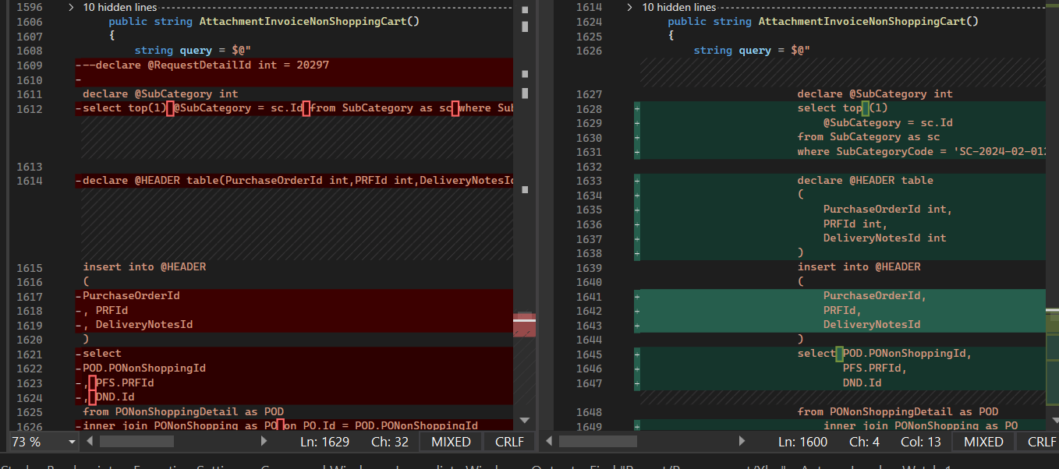
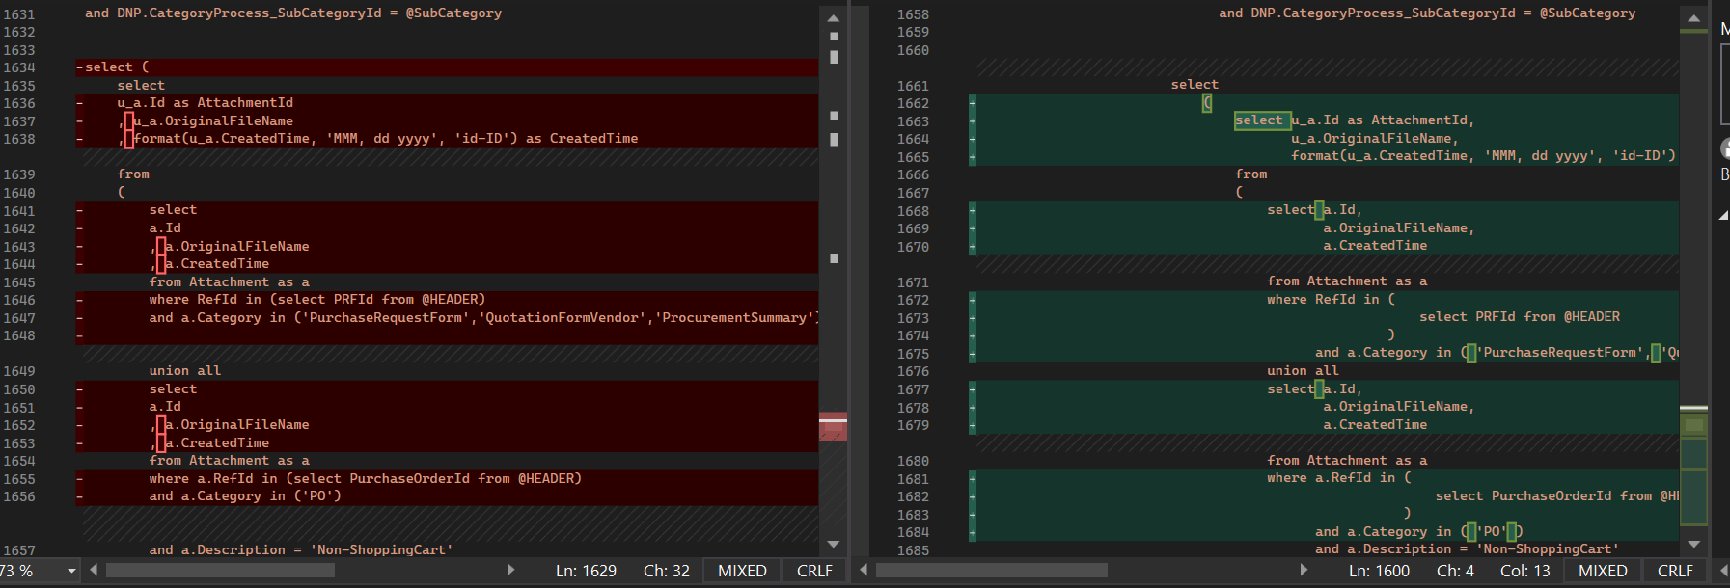

WEB

